

CEGEG090

Web and Mobile GIS

Technical report

Man Hei Lee

Option A – Location based Quiz  
08/05/2018

Contents

1. Introduction 1

1.1 Summary 1

1. User guides and technical guides 2

2. Question Setting App 2

3. Quiz App 2

4. Server 3

# 1. Introduction

## 1.1 Summary

This assignment is about the creating of two Android-based apps which serve two major functions for questions creators and end-users. The first app allows the creators to set questions with four answers as options (MC questions) as well as their specific coordinates. The second app allows end-users to answer the questions when they are at close proximity to the coordinates selected by the creators.

The whole project has three components. Two of them are the two Android-based apps mentioned. The third component is the server. The purpose of the server is to communicate between the two apps and the database. Therefore, there are four elements in total, they are the Question Setting App (QSA), Quiz App (QA), NodeJS server and database. There relationships are described in the following map, Figure 1.1.

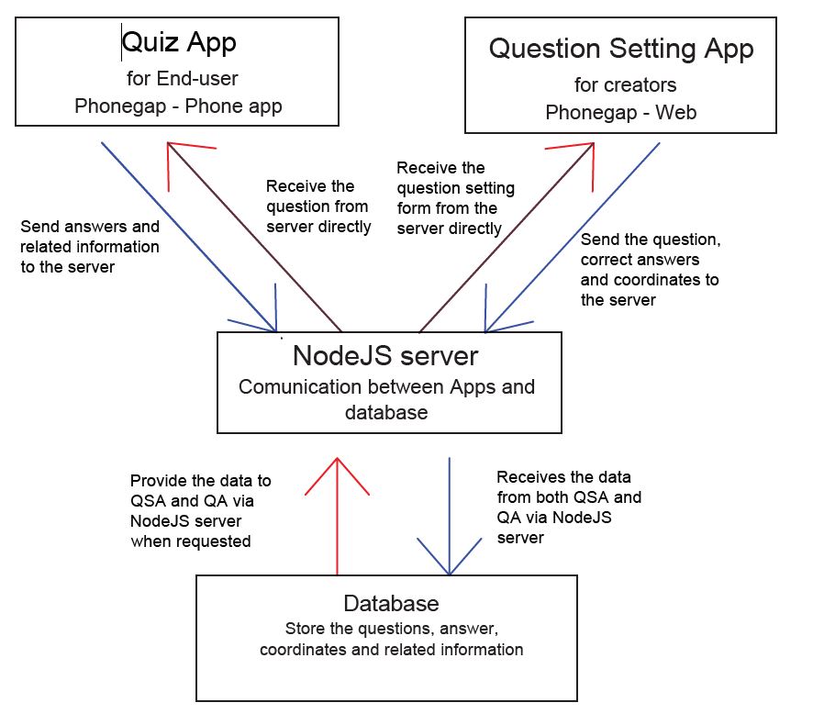

Figure 1. 1. Big picture of the 3 components

# User guides and technical guides

For user guides, please click the “open user menu” button in both of the Apps. They describe the general steps of using the Apps for creators and users.

For technical guides, please refer to the READ.md file in each of the 3 repositories (Quiz_Server, Quiz_App and Question_Setting) in Github, link: https://github.com/bruce338181920/. They describe the technical procedure to start the servers for Node JS server and the Apps.

# Question Setting App

This App, as mentioned before, allow creators to set the questions simply by clicking on any point on the map to set the physical range of the questions. The creators can enter the questions and four answers. The app comes with other functions such as deleting the old question and tracking the location of the old questions.

The code mainly gives the following function:

* Track the point clicked on the map
* Auto recorded the location (coordinate) of the point clicked
* Show user meun
* Save the questions, answers and coordinates to the server and upload them to the database

# Quiz App

The Quiz App allow end-users to answer the questions. It has a map for the user to walk to the specific location in order to do the test.

The code mainly gives the following function:

* Track end-user’s locations
* Trigger the pop-up of the question
* Save the answer, phone id and related information to the database via the server

# Server

The server is the bridge between the two apps and the database. Although it does not look important to laypersons, it is vital to the whole assignment. The only file, “appserver.js”, which runs this server is responsible for uploading data from the app to the database and retrieving data from the data base to the apps. Without this, the app will have no value as data cannot be stored on the database